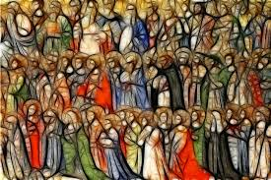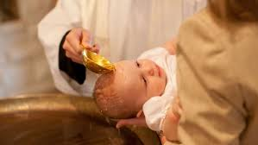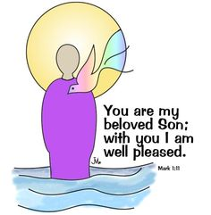

**KEY VOCABULARY**

promises rules actions symbols rite

Sacrament commitment anointing Trinity

The promises made at Baptism and Confirmation are the call to a new way of life.

Belonging to a group involves promises and rules.

The first *“profession of faith”* is made during Baptism.

**OUR BIG QUESTION**

What makes a promise?

**PROMISES**

Year 3 Topic 2

**REFLECTION**

Almighty and eternal God,

you keep together those you have united.

Look kindly on all who follow Jesus your Son.

We are all consecrated to you by our common baptism;

make us one in the fullness of faith

and keep us one in the fellowship of love.

Amen.

**SCRIPTURE**

Jeremiah 31: 3

Mark 1: 9-11