

English Martyrs Catholic Voluntary Academy – Year 2 Everyday Materials Knowledge Organiser
We grow and learn, with the gifts we have been given, following in the footsteps of Jesus.

Working Scientifically
Ask simple questions and recognise they can be answered in different ways | Observing closely using, simple equipment | Perform simple tests | Identifying and classifying | Use observations and ideas  to suggest answers to questions | Gathering and recording data to help in answering questions

What I should already know
- Distinguish between an object and the material from which it is made
- Identify and name a variety of everyday materials, including wood, plastic, glass, metal, water, and rock
- Describe the simple physical properties of a variety of everyday materials
- Compare and group together a variety of everyday materials on the basis of their simple physical properties.
What I will know by the end of the unit
The suitability and uses of everyday materials | We use different materials for different objects depending on their purpose and the properties of the material.  Materials are used for more than one thing (e.g. metal can be used for coins, cans, cars and table legs.  Think about unusual and creative uses for everyday materials.
How the shape of solid materials can be changed. | 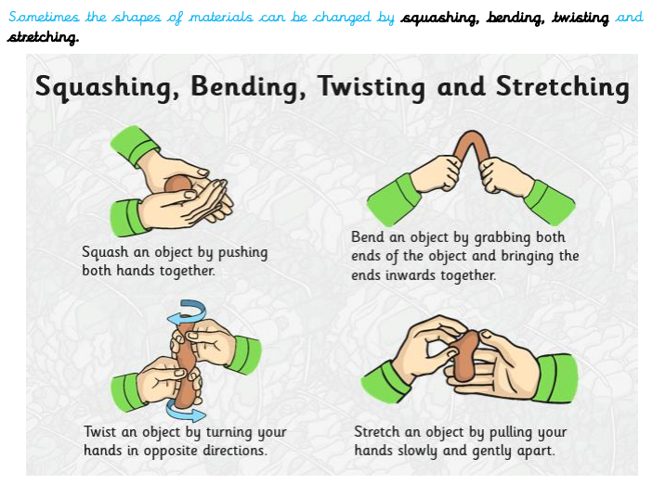
Key Vocabulary
Material | A substance used to make things
Property | A characteristic of something
Waterproof | Not allowing water to go through.
Purpose | What the object is used for.
Suitability | Something being right for its purpose.
Compare | To look at the similarities and differences.
Change | To make or become different.
Investigate | To try and answer questions by looking and doing tests.
Squashing | To press, beat or crush to make a flat shape.
Bending | To change a straight object so that it is curved.
Twisting | To change the shape of an object by turning it.
Stretching | To make an object longer or wider without tearing or breaking.

Types of material
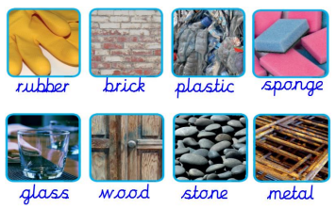

Investigate
Find an object in your house that can be made from different materials. Which one do you think is best? Why?

What material makes the strongest bag? Why? How could you investigate this?

What investigations can you think of to do to test which material is best for the job. What question are you trying to answer? What will you measure? What will stay the same in each test?

People we need to know
Charles Macintosh | 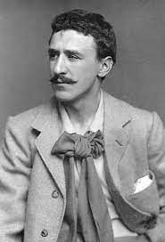 | - Born in 1766 in Scotland.  - Investigated ways to make new fabrics.  - Invented the first waterproof fabric using rubber and woollen cloth.  - The Mackintosh or Mac (Type of waterproof coat) is named after him.
Dr Pearl Agyakawa | 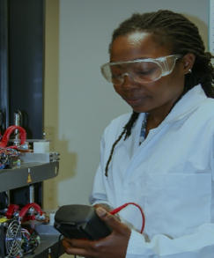 | - She is a Materials Scientist at Nottingham University now.  - She is investigating why different materials behave the way they do, why we make something out of one material rather than another and why materials wear out.  - This will help to design materials that last longer which is good for the planet.

Useful links/books to read
https://www.bbc.co.uk/bitesize/articles/z9pgcdm
The Great Paper Caper – Oliver Jeffers http://quietube7.com/v.php/http://www.youtube.com/watch?v=32O6Xk3A2J0
Rosie Revere Engineer – Andrea Beaty and David Robert
A planet full of plastic – Neal Layton
Brick – Joshua David Stein and Julia Rothman.
Properties of different materials
Wood | strong, opaque, stiff, hard
Plastic | bendy, smooth, translucent, stretchy
Glass | transparent, hard, smooth, waterproof
Brick | rough, strong, opaque, dull
Paper | translucent, flexible, not waterproof
Cardboard | rough, dull, opaque, not waterproof
Metal | Shiny, strong, opaque, hard

